**BHE0013 ICT INSTRUCTIONS**

**(WITH EXAMPLE QUESTION AND ANSWER INSTRUCTIONS)**

MARCH-APRIL 2025

**ICT INSTRUCTIONS**

1. This is an unseen computer based open book ICT with no access restrictions to the materials. However, please note that this is your individual work. You **MUST NOT** interactwith other students while under the exam conditions. As you will use a university PC with access to the internet, you also cannot interact with others over the web/mobile messengers, etc; you are given the internet access to work with the module materials on the Brightspace, university library, etc.
2. You will have 2 hours (120 minutes) to finish your ICT.
3. You must answer all questions to score maximum marks.
4. Before ICT starts:
   1. Put your student id card on the desk so that it is visible and accessible for invigilators.
   2. Start your university computer and login using your university credentials.
   3. Create and save a new empty MS Word document.
   4. Double check that you know where this document is saved/located on the university PC. It may be desktop/documents/OneDrive/Dropbox, etc.
   5. Double check that AutoSave is on. It is also worthwhile to save your document as you progress.

**REMEMBER THAT IT IS YOUR RESPONSIBILITY TO SUBMIT YOUR WORK.**

* 1. Name the document: **BHE0013 ICT ANSWER STUDENTID**

1. Your ICT will appear and become available to you on the module’s Brightspace page under the **Assessment -> Assessment Task Two** rightbefore the ICT starts. You can find this document also located there. Please ensure that you can navigate module’s Brightspace page and can identify the submission point before the exam starts.
2. You must save and close your ICT Answer document once time allocated to the ICT is finished. You will be given time to submit your answer on the module’s Brightspace page under **Assessment -> Assessment Task Two.** Submission point will become available to you prior the ICT starts.

**Example Question**

A policymaker is aiming to investigate the impact of the minimum drinking age legislation in the USA. As their first step, the policymaker would like to use the standard dataset for the United States traffic fatalities. They installed and loaded necessary packages, data, preformed data transformations and filtering, and run a simple regression of the minimum drinking age impact on the mortality rate as shown in the *code snapshot example.* Their regression output is provided in the *console output snapshot example.*

**Code snapshot example (a):**

# install.packages("remotes")

# remotes::install_github("jrnold/masteringmetrics",

# subdir = "masteringmetrics")

#

library**(**"masteringmetrics"**)**

library**(**"dplyr"**)**

#

data**(**"deaths"**)**

drinkage **=** deaths

drinkage **=** drinkage %>% filter**(**year **<** 1984**)** %>%

group_by**(**state, year**)** %>% distinct**(**legal1820, .keep_all **=** T**)**

drinkage**$**state **=** as.factor**(**as.character**(**drinkage**$**state**))**

#

reg_q **=** lm**(**mrate **~** legal1820, data **=** drinkage**)**

summary**(**reg_q**)**

**Console output snapshot example:**

Call**:**

lm**(**formula **=** mrate **~** legal1820, data **=** drinkage**)**

Residuals**:**

Min 1Q Median 3Q Max

**-**69.124 **-**16.440 **-**1.944 11.799 111.354

Coefficients**:**

Estimate Std. Error t value Pr**(>|**t**|)**

**(**Intercept**)** 92.296 1.469 62.81 **<** 2e-16 **\*\*\***

legal1820 **-**5.699 2.072 **-**2.75 0.00611 **\*\***

**---**

Signif. codes**:** 0 ‘**\*\*\***’ 0.001 ‘**\*\***’ 0.01 ‘**\***’ 0.05 ‘.’ 0.1 ‘ ’ 1

Residual standard error**:** 24.29 on 712 degrees of freedom

Multiple R**-**squared**:** 0.01051, Adjusted R**-**squared**:** 0.009122

F**-**statistic**:** 7.564 on 1 and 712 DF, p**-**value**:** 0.006107

*Note that this is a dataset on the minimum drinking age across 50 states in the US over the 1970 – 1983. Prior to the 1984 each state could introduce their own minimum age, while since 1984 it is set on the federal level at the age of 21. Your key variables are legal1820 – proportion of the 18–20-year-olds who can legally purchase alcohol. The closer this value is to 1, the higher is the share of 18–20-year-olds who can purchase alcohol legally in the state. The second key variable is mrate – mortality rate (deaths per 100.000 people). States are denoted with their FIPS codes; numeric labels to identify the state geographically.*

1. Interpret regression output in the *console* *snapshot example*. Do regression results match your expectations? Do you think that the policy maker chosen an appropriate model for estimations? If yes(no), why? (10 out of 30)
2. Suggest improvements for the regression model in the *console snapshot example.* Your answer must explain how your suggested improvements/models capture the properties(nature) of the dataset used for investigations. Highlight advantages and disadvantages of the approach(es) you suggest. **Hint:** you are provided with all necessary information on variables that you need to answer this part of the question. (10 out 30)
3. Demonstrate that your suggested models in the section **(B)** improve output in the *console snapshot example.* Use appropriate test(s) to demonstrate your final model selection.

**You must provide R code used for your estimations and console output similar to the *code snapshot example* and *console output snapshot example* for all model(s) and test(s) you run.** (10 out of 30)

**THIS IS AN ILLUSTRATIVE QUESTION FOR ANSWER INSTRUCTIONS ONLY – FULL ANSWER IS NOT PROVIDED**

**ANSWER INSTRUCTIONS**

Before you start answering the question, if you are given a code snapshot, it is worthwhile copying it contents into the software and checking if it runs or simply explore the dataset. It may contain hints towards the correct answer. Plus, you are likely to modify/correct the code you were given, and it is always convenient (time efficient) to work on what has been already provided to you (especially given that you have limited time).

Code snapshots are interactable, and you can copy and paste their contents from word document into R/RStudio scripts/files and back.

You must clearly specify what question and section of the question you are answering. Such as:

**Example Question A)**

*The policy maker is using a simple linear regression model to investigate how minimum drinking age is linked to the mortality rate. From the provided output, it can be observed that intercept and legal1820 variables are both statistically significant. With intercept stat. significant at 0.1% and legal1820 at 1%. Coefficient for legal1820 variable is negative and is in line (or not in line) with expectations/theory because, etc, etc.*

Note that you are expected to demonstrate depth of the knowledge you accumulated through the module and shall be able to grab the context of the question from the information provided, sometimes by digging into the data a bit using software and understanding its basic structure. It is easy to spot that this is a panel dataset (why?), so what is likely wrong or right here (why)? What methods to use or not to use? Do not forget there are a lot of marks for the actual code and console output. Therefore,

**Example Question C)**

Instructions on how to effectively transfer code or console output and keep your ICT document format tidy.

1. Produce desired code/output in R/RStudio.
2. Find and open **Notepad++** using search bar as shown on the print screen below:

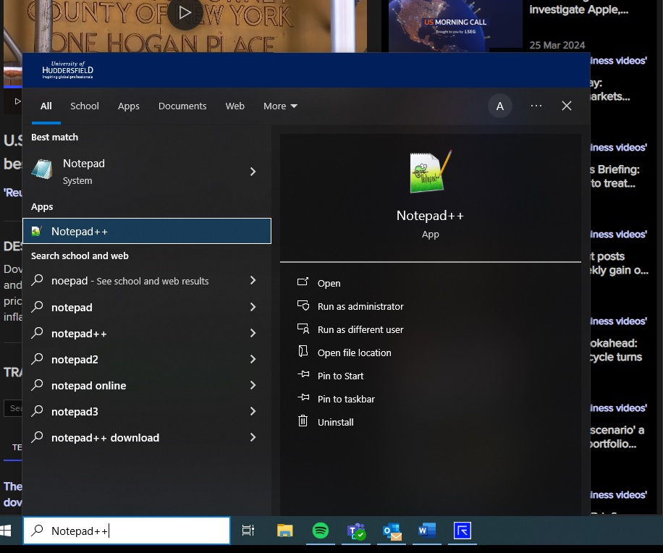

1. Set correct programming language in the Notepad++ with **Language -> R ->R** as shown on the print screen below (in our case it is R):

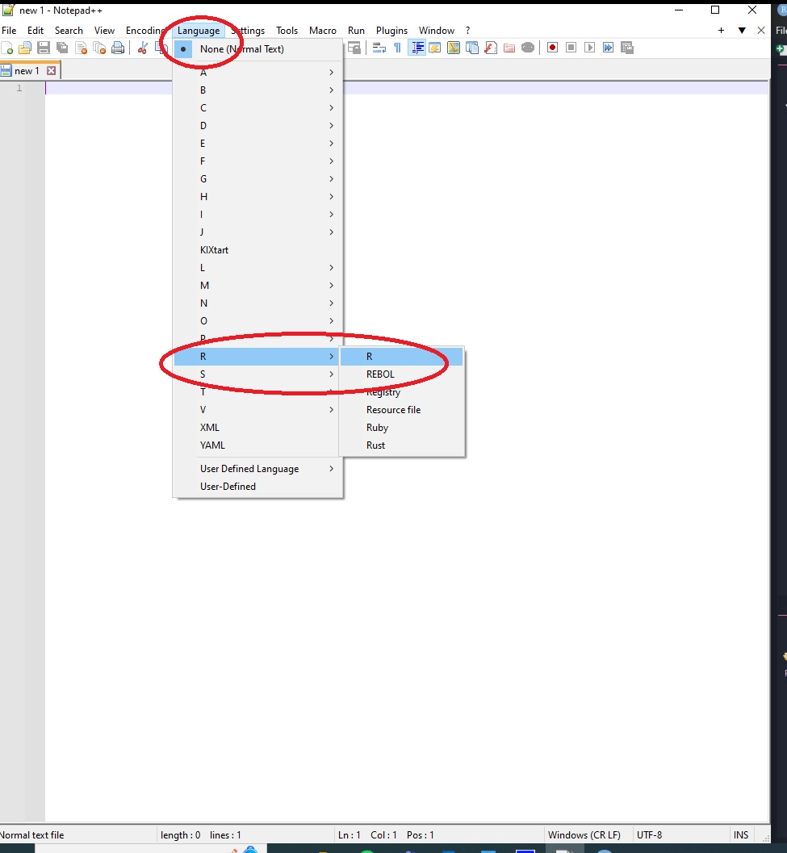

1. Go to RStudio and copy your code/output by **first selecting your code in RStudio, then right click on the selection and select copy** as shown on the print screen below:

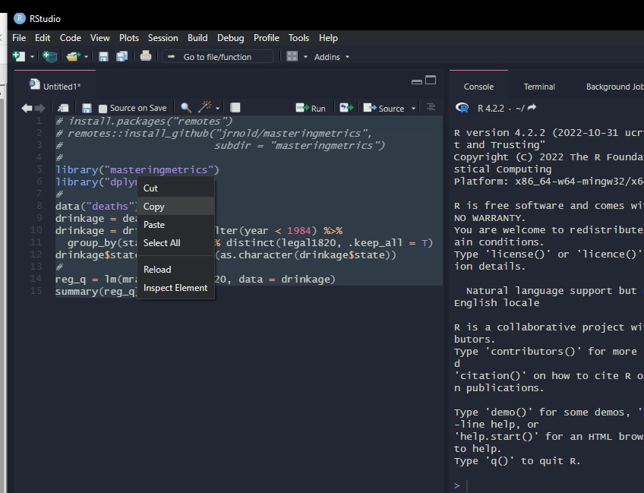

1. Go back to Notepad++, **right click where you would like R code/output to be inserted and then select paste** as shown on the print screen below:

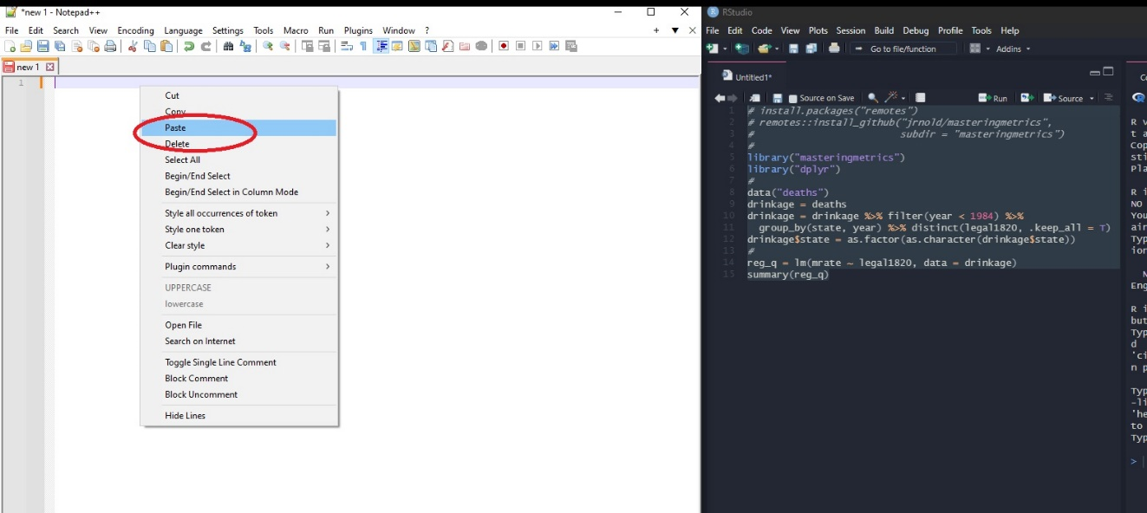

1. Once you copied your code/output from RStudio and pasted it to Notepad++, select your code/output in Notepad++ and go to **Plugins -> NppExport -> Copy HTML to clipboard** as shown on the print screen below:

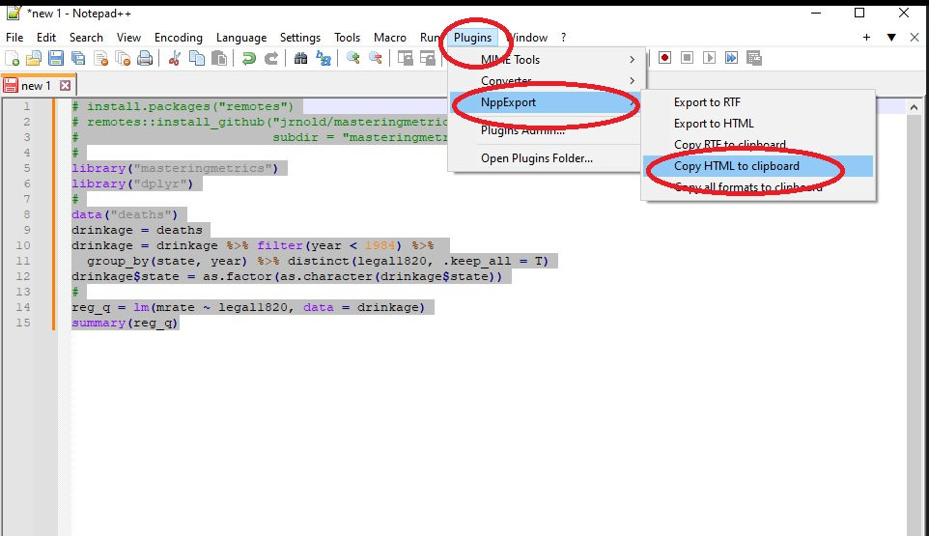

1. Go to your ICT answer document, **right click** where you would like your code/output to be inserted and select **paste with keep the source formatting** option as shown in the print screen below:

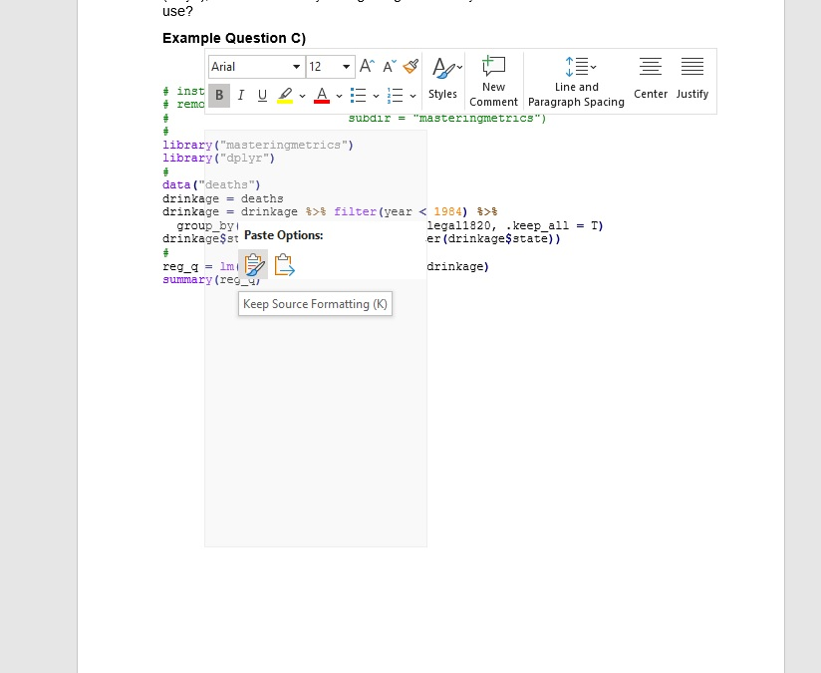

As it can be clearly observed, the above steps shall keep your code/output part of the answer tidy and stick to the native R/RStudio format. This will ensure that your answer is readable and easy to mark.

THESE INSTRUCTIONS ARE AVAILABLE TO STUDENTS WELL IN ADVANCE OF THE ACTUAL ICT DATE.

IT IS STUDENTS’ RESPONSIBILITY TO PREPARE FOR THE ICT INCLUDING PRACTICING WITH FORMATTING AND SUBMITTING THEIR ANSWER.

END OF THE INSTRUCTIONS